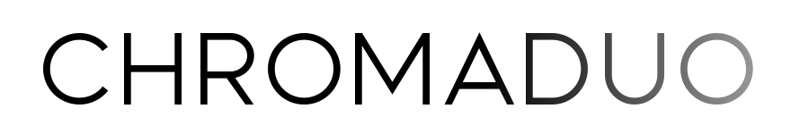
"Simply put, everything I heard blew my mind."
~ Jean-Baptiste Collinet
One of North America’s leading guitar ensembles, ChromaDuo shares uncommonly beautiful music with audiences throughout the world. For the past fifteen years, Tracy Anne Smith and Rob MacDonald have concertized across their native Canada and throughout the United States, as well as in Mexico, England, and Germany.
Passionate advocates for their art form, their deep creative connection allows audiences to immerse themselves more fully into the music. From the critic who stated, “their exchanges seem almost symbiotic, and profoundly moving as if the instruments were corporeal rather than of wood, nylon and brass,” (James Filkins) to the elementary-school student who revealed, “the music made me see Paris in a way,” (Dawson), the duo aims to provide a sincere, timeless experience for each listener. The Iserlohner Zeitung observed, “As ChromaDuo sounded the first harmonies, you could hear a pin drop in the house of worship. Smith and MacDonald immediately captivated the audience.”
They are the dedicatees of works by top composers, including French classical-jazz virtuoso Roland Dyens, British iconoclast Stephen Goss, Canadian virtuosa Dale Kavanagh, and musical polyglot Dušan Bogdanović. In the 2022/23 season they commissioned and premiered works by legendary Cuban maestro Leo Brouwer, uncanny Canadian composer Amy Brandon, and iconic Brazilian artist Sergio Assad.
As Naxos recording artists, their music can be heard on all major streaming platforms. Their debut release Hidden Waters contains five world premieres, while original arrangements of French Impressionist works shine in their sophomore recording Ravel and Debussy, Music for Two Guitars. With support from the Canada Council of the Arts, a third recording of world premieres is planned for late 2023. Sergio Assad predicted that ChromaDuo’s oeuvre would not only “enter and enrich the traditional repertoire of guitar duos across the world in the coming years,” but that it “would have a larger impact: it will further sediment guitar duos, this great way of expressing musical art.”
They have performed, taught, and adjudicated competitions at major festivals of the guitar world including the GFA, Boston’s Festival 21, 30th International Guitar Festival Iserlohn, and Festival Internacional de Guitarra Sinaloa, Culiacán.
ChromaDuo’s music is heard on various radio programs and stations, including Canada’s CBC, RadioFrance, National Public Radio, Hong Kong’s RTHK, Sweden’s Sveriges Radio, Netherlands’ NPO Radio4, WFMT in Chicago, Minnesota Public Radio, Classical Guitar Alive, WFMU’s Shrunken Planet, and The Third Floor on PRX (Public Radio Exchange). The two have created an ever-growing ChromaDuo Collection with publisher Productions d’Oz, made up of dedications and commissioned works. As Savarez artists, they are proud to sculpt their sound with Savarez strings.

